Cheat Sheet for important parts for coding a LCS Python Simulator

Importing Libraries
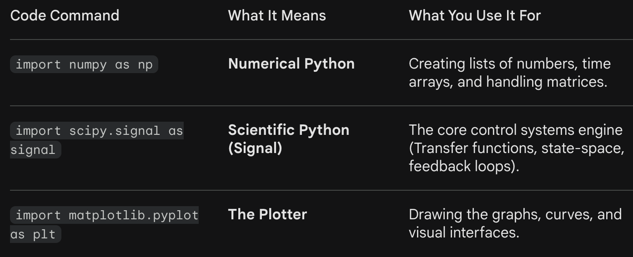

Representing Arrays
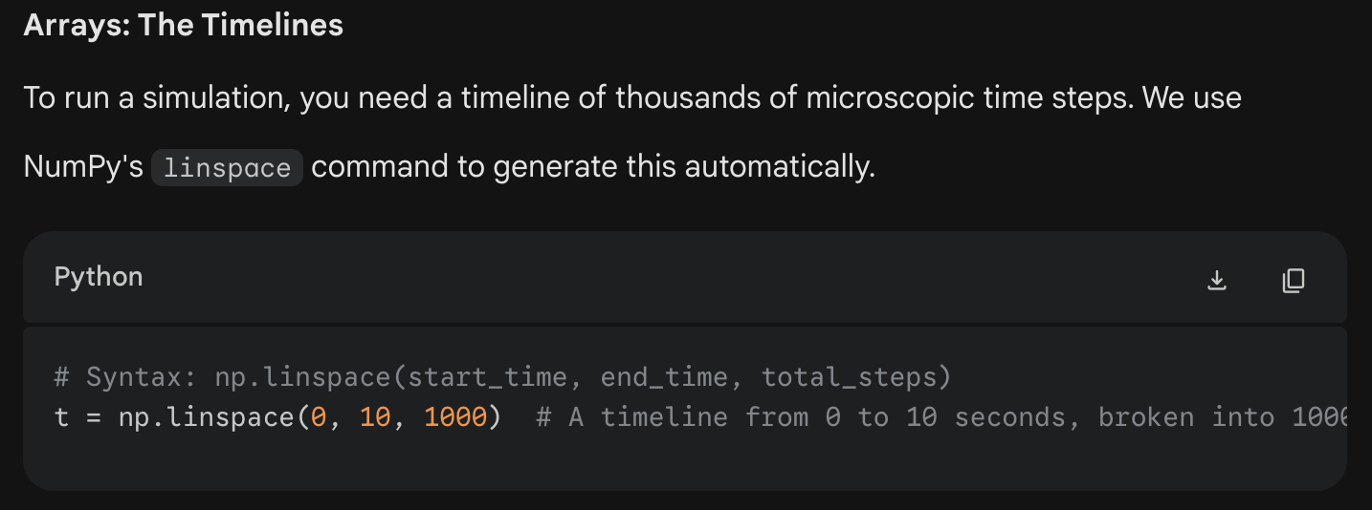

Representing Lists
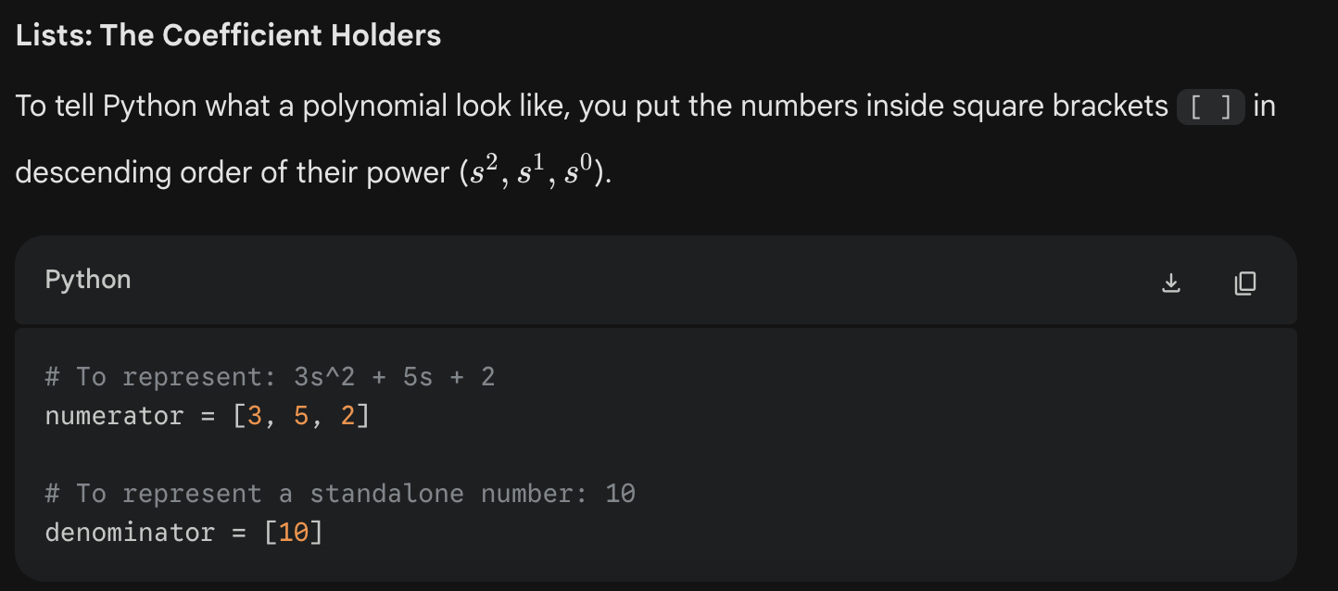
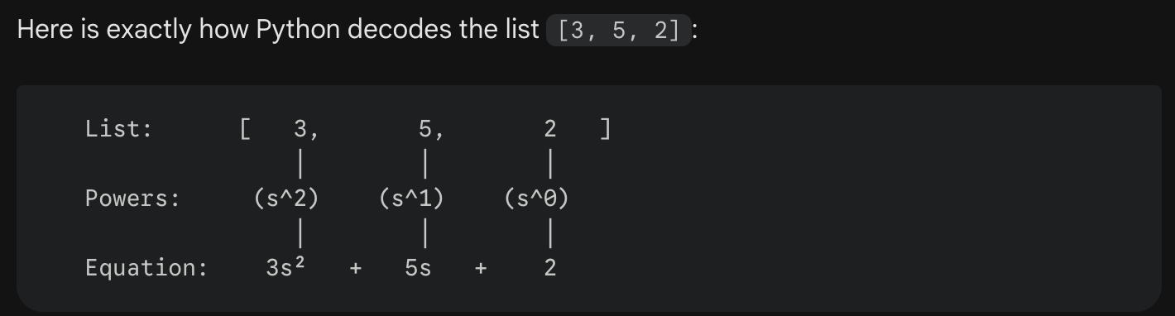
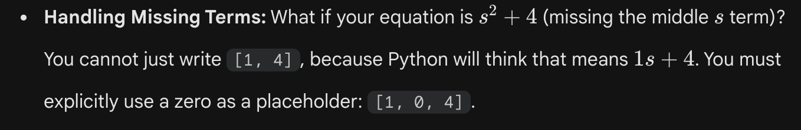

linspace (Timeline Maker) – Use to make equidistant values over a range. Official name is “Linearly Space Vector”
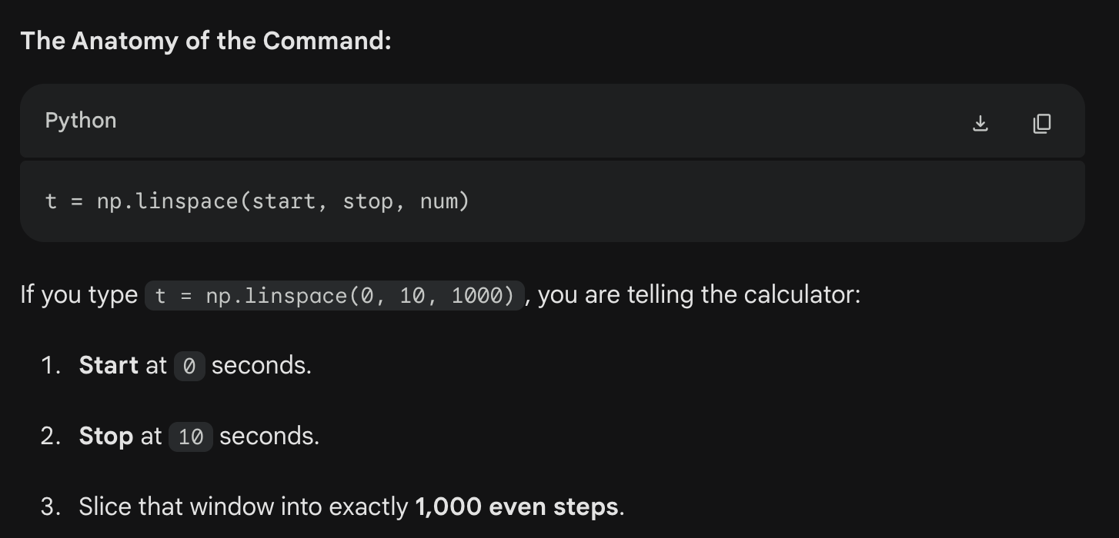

Transfer Function Generation
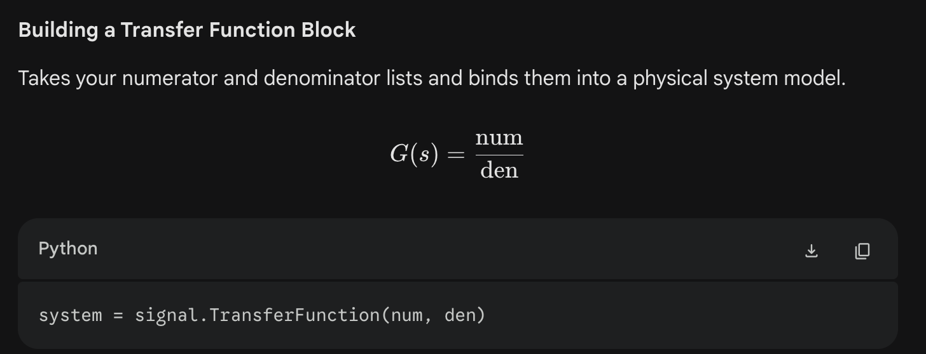

Input Types
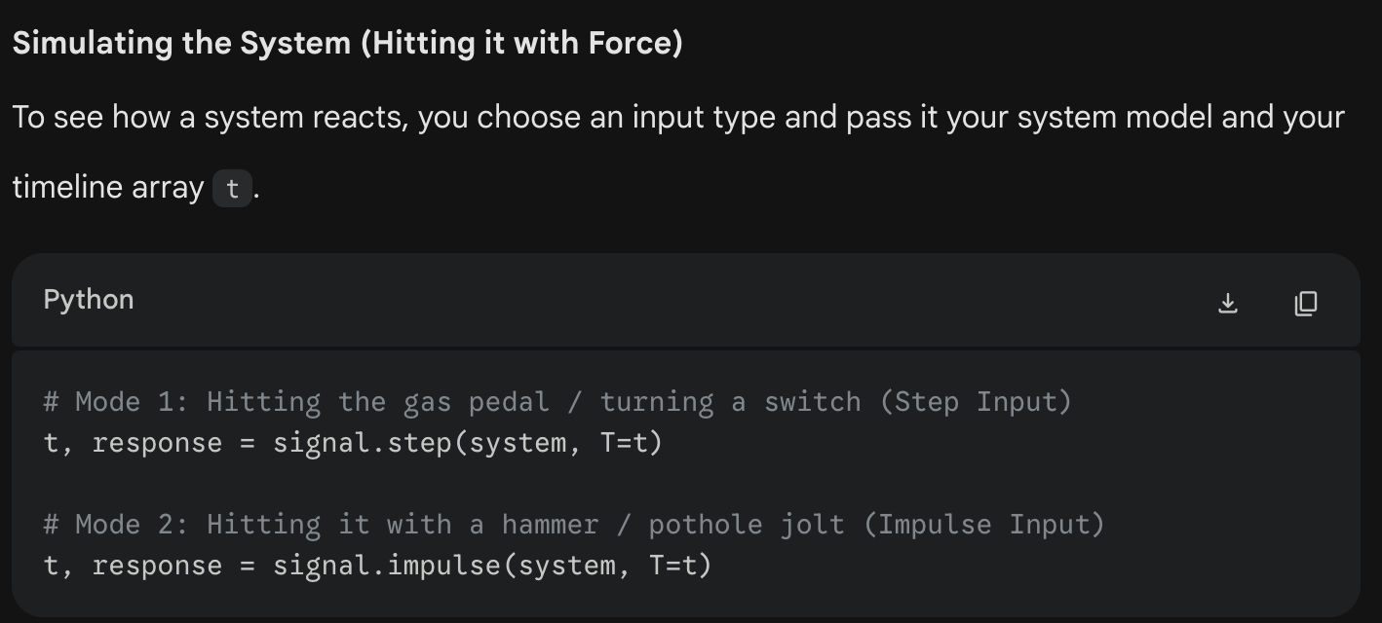

Feedback Loops
Assuming we have an Open Loop TF stored in the variable open_loop_sys.
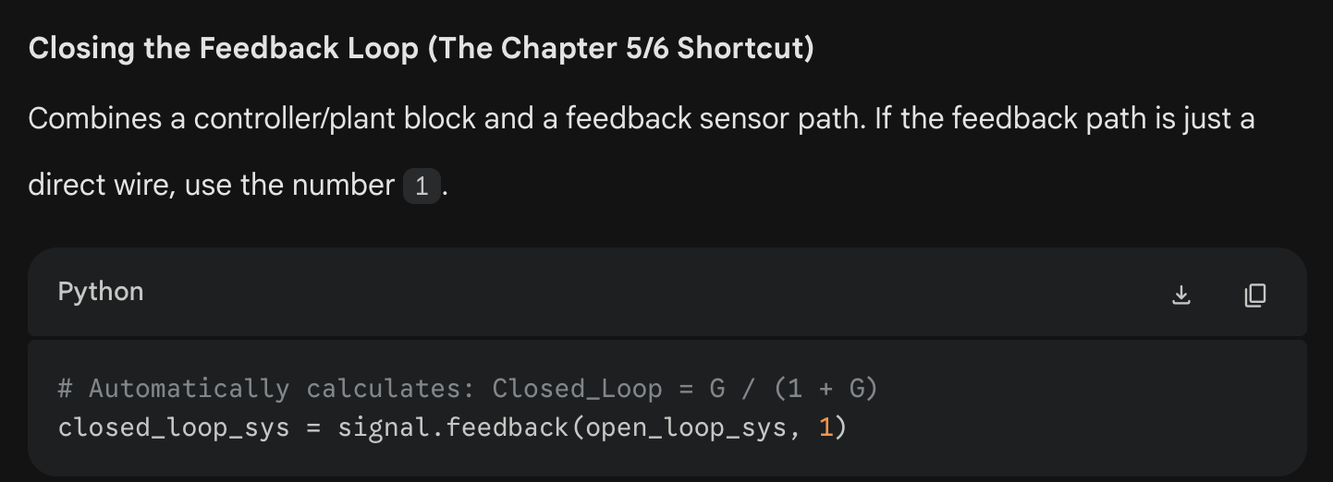
x

xxx.convolve – Convolve is used to multiply two polynomials. We can use it to find open loop systems G(s)H(s) by multiplying the numerators and denominators separately then recombining them using [xxx.TransferFunction()]
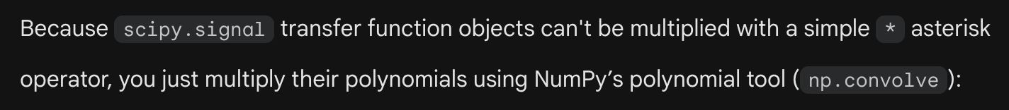
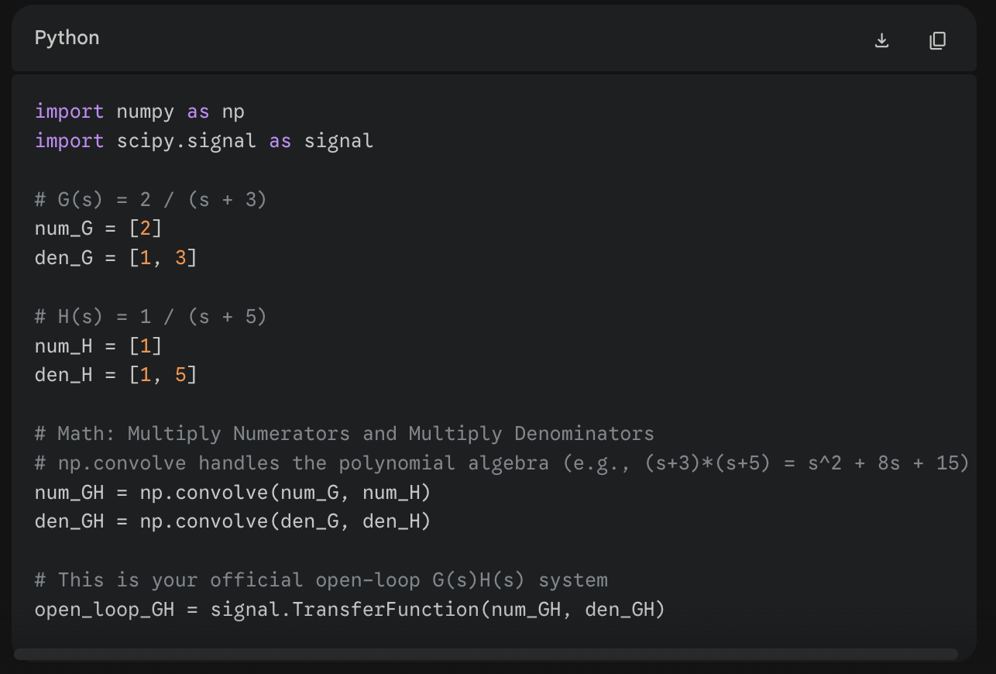

Basic Visual Interface
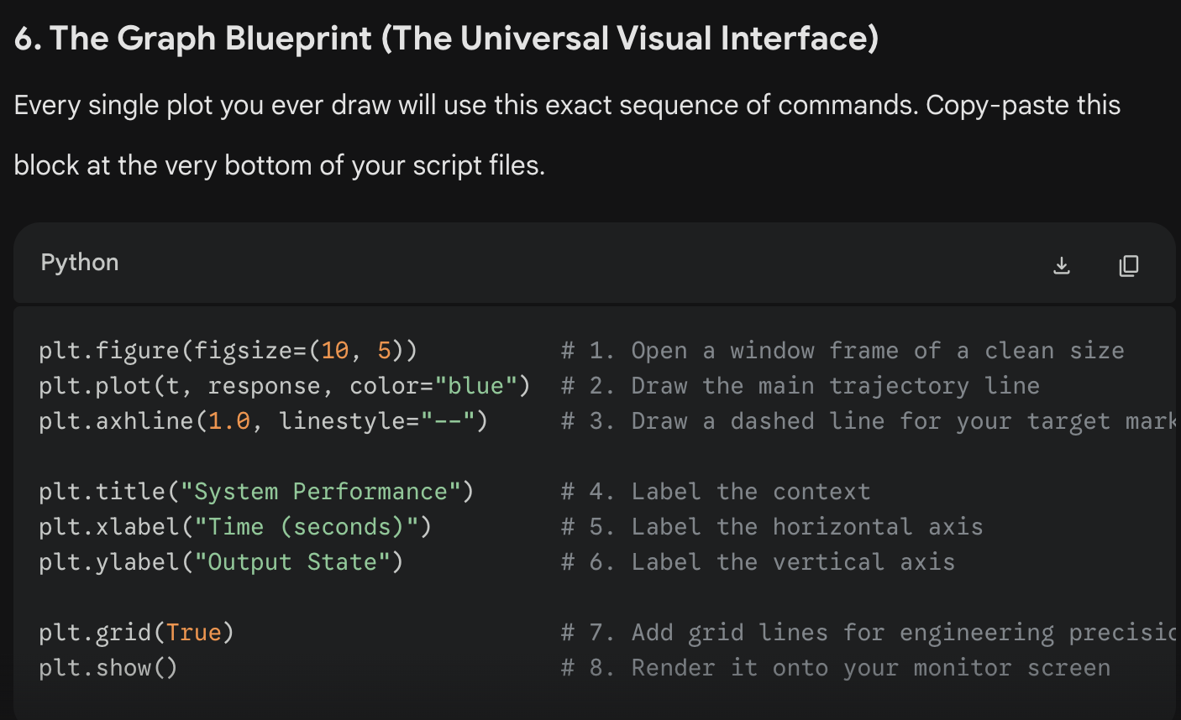

State-Space Representations
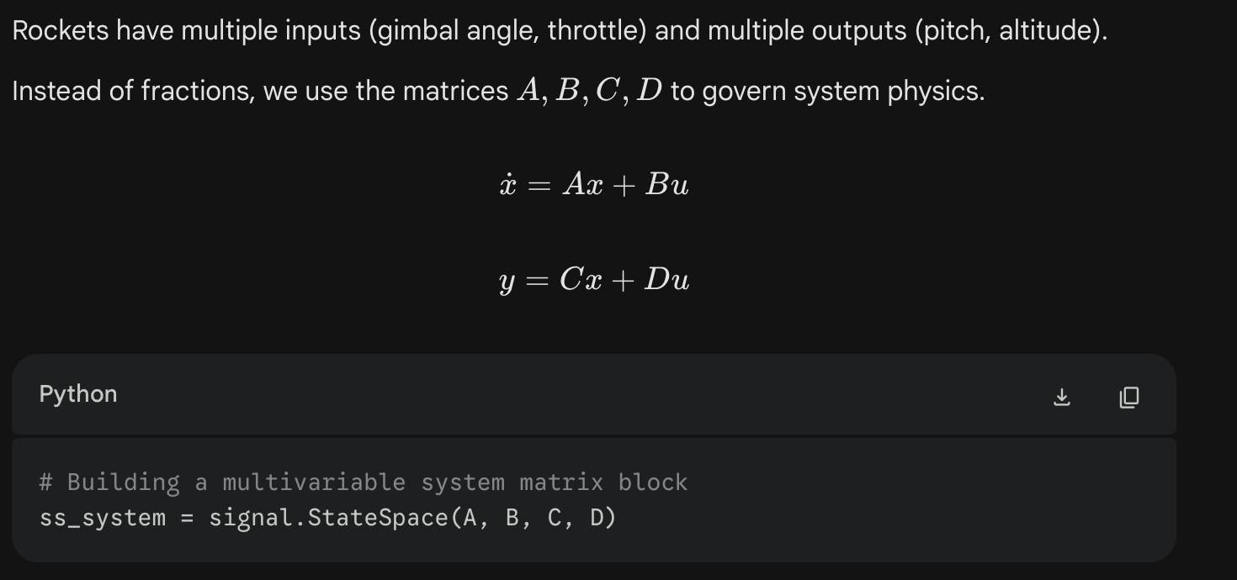

Array Math Slicing (Tracking States) for specific states
